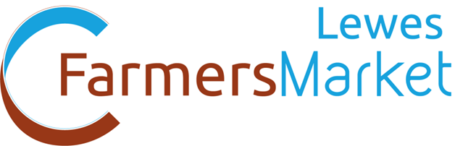
Common Cause Cooperative,
The Hive, 66 High St, Lewes
BN7 1XG.

07555 902677
lewesfarmersmarket@gmail.co.uk
www.commoncause.org.uk

STALL APPLICATION FORM 2018

Your details:
Business name
Producers’ name
Address

Phone Number
Mobile Number
Email
Website

Details of product ranges you intend to sell

Please tell us about the ingredients that you use, please name all of the ingredients and suppliers. If they are not local please tell us what is the % of the final product. Use an additional sheet if necessary.

Are your premises registered with your local Environmental Health Department?
Yes |  | No |  | If yes, please provide
Name of Council
Date of last EHO inspection

Are you a member of any assurance certification scheme?
Yes |  | No |  | If yes, please enclose copy of certification

Are you selling Alcohol?
Yes |  | No |  | If yes, please enclose copy of Licence

Please note: Stallholders/producers must have Public Liability Insurance cover (min. £5million) and where applicable, Product and Employee cover to attend. Copy certificates must be enclosed
Name of Insurer
Policy Number
Date of Expiry

Declaration
By submitting this application I/we agree to the following:
- I/we confirm the information supplied by us is correct.
- I/we have read and fully agree to the Criteria and Guidelines for the Lewes Farmers Market.
- I/we will only sell products listed here and as agreed with the Market Manager.
- I/we declare that I have read & understood the Weather Policy.
- I will inform Common Cause of any changes in products for sale, my production methods or sourcing practice
- I/we will keep my Product & Public Liability up to date.
- I/we understand & agree to the Common Cause 48 hour cancellation fee so that if I do not give written due notice of non-attendance I will be liable for the pitch fee.
Business Name
Signed

Name
Position
Date

Please return this form by email to:

lewesfarmersmarket@gmail.com

or post to:

Lewes Farmers Market,
Common Cause Co-operative,
The Hive, 66 High Street
Lewes, East Sussex
BN7 1XG

Please ensure you have included the following:
please tick or put an X in the box(es) as applicable (adding others if included)
Current Public and Product Liability insurance certificate
Environmental Health Score
Organic certification or registration with other certification bodies
Copies of any Licences
Gas Safety Certificate
PAT test documentation

STALL:
2018 Lewes Farmers Markets you wish to attend
January | 6th |  | 20th
February | 3rd |  | 17th
March | 3rd |  | 17th
April | 7th |  | 21st
May | 5th |  | 19th
June | 2nd |  | 16th
July | 7th |  | 21st
August | 4th |  | 18th
September | 1st |  | 15th
October | 6th |  | 20th
November | 3rd |  | 17th
December | 1st |  | 15th

